**Vivekanand Education Society’s** 

**Institute of Technology**

**(Affiliated to University of Mumbai, Approved by AICTE & Recognized by Govt. of Maharashtra)**

**Department of Information Technology**

A.Y. 22-23

MAD & PWA Lab

Journal

| Experiment No. | 04 |
| --- | --- |
| Experiment  Title. | To create an interactive Form using form widget |
| Roll No. | 53 |
| Name | SAKSHI SANTOSH PATIL |
| Class | D15B |
| Subject | MAD & PWA Lab |
| Lab Outcome | LO2: Design and Develop interactive Flutter App by using widgets, layouts, gestures and animation |
| Grade: |  |

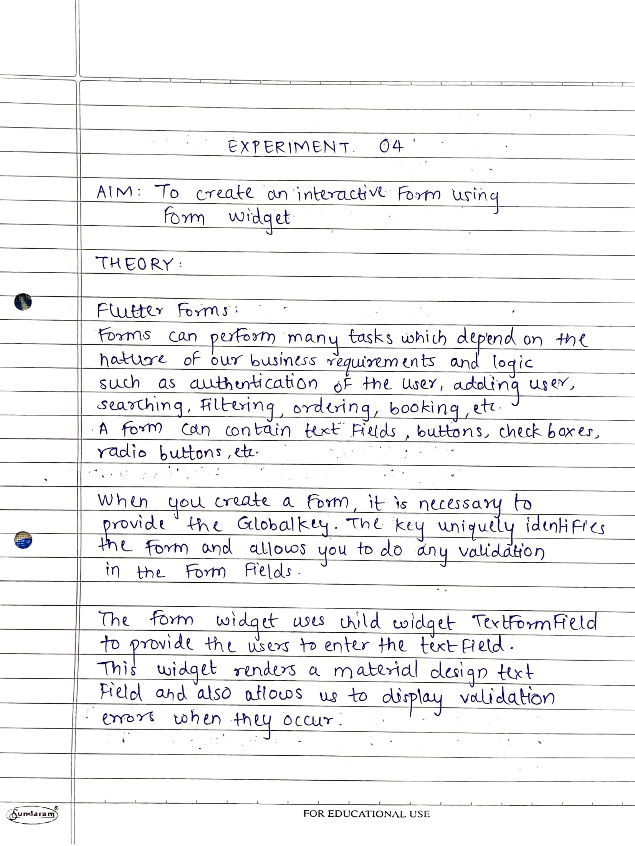

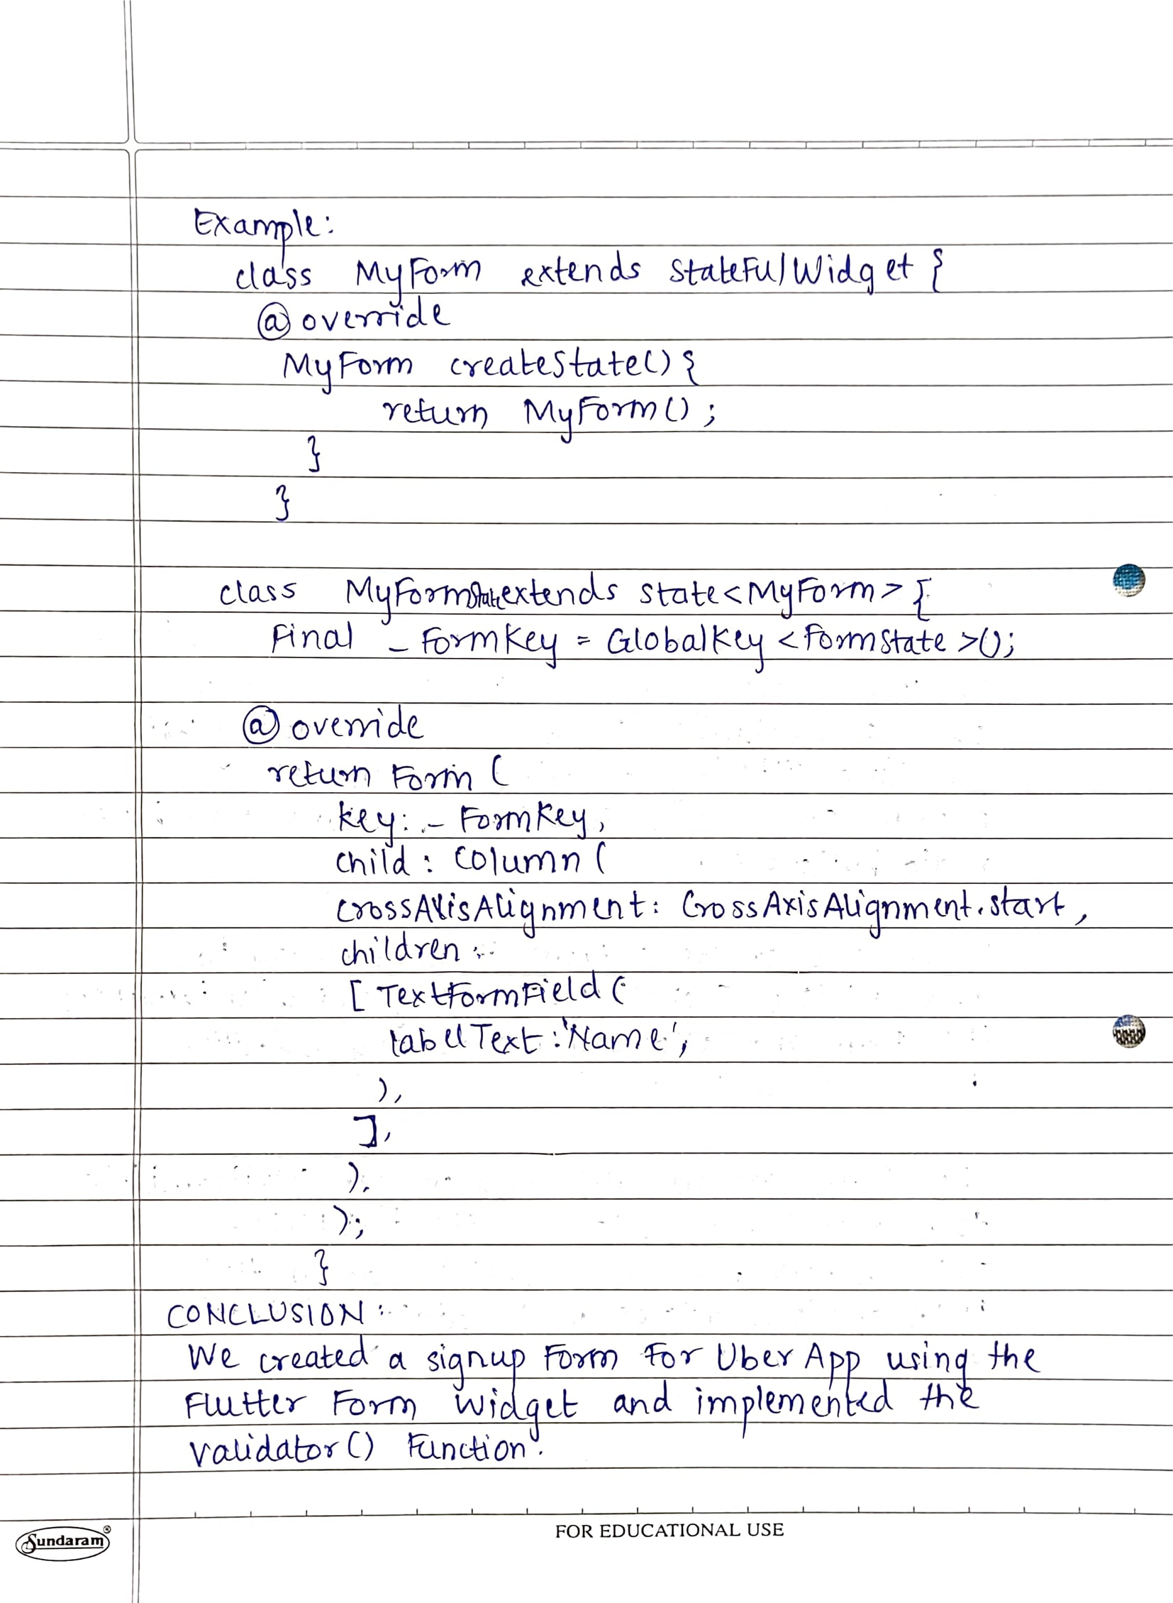

**AIM:** To create an interactive Form using form widget

**CODE:**

**main.dart**

import 'package:flutter/material.dart';

import 'package:uber_clone/screens/splashScreen.dart';

void main() {

runApp(const MyApp());

}

class MyApp extends StatelessWidget {

const MyApp({Key? key}) : super(key: key);

@override

Widget build(BuildContext context) {

return MaterialApp(

title: 'Uber',

theme: ThemeData(

fontFamily: "Brand-Bold",

primarySwatch: Colors.*blue*,

visualDensity: VisualDensity.*adaptivePlatformDensity*),

home: SplashScreen(),

debugShowCheckedModeBanner: false,

);

}

}

**registrationScreen.dart**

import 'package:flutter/material.dart';

import 'package:uber_clone/screens/loginScreen.dart';

class registrationScreen extends StatefulWidget {

const registrationScreen({Key? key}) : super(key: key);

@override

State<registrationScreen> createState() => _registrationScreenState();

}

class _registrationScreenState extends State<registrationScreen> {

// static const String idScreen ='register';

final _formkey = GlobalKey<FormState>();

@override

Widget build(BuildContext context) {

return Form(

key: _formkey,

child: Scaffold(

resizeToAvoidBottomInset : false,

backgroundColor: Colors.white,

body: SingleChildScrollView(

child: Padding(

padding: const EdgeInsets.all(8.0),

child: Column(

children: [

SizedBox(height: 40.0,),

Image(image: AssetImage("images/Uber-logo-255-150.jpg"),

height: 140.0,

width: 390.0,

alignment: Alignment.center,),

// SizedBox(height: 0.0),

Text(

"Signup",

style: TextStyle(fontSize: 26.0, fontFamily: "Brand-Bold"),

textAlign: TextAlign.center,

),

Padding(padding: EdgeInsets.all(45.0),

child: Column(

children: [

// SizedBox(height: 1.0,),

TextFormField(

validator: (value){

if(value==null || value.isEmpty){

return 'Please enter some text';

}

return null;

},

keyboardType: TextInputType.text,

decoration: InputDecoration(

labelText: "Name",

labelStyle: TextStyle(

fontSize: 14.0,

),

),

style: TextStyle(fontSize: 14.0),

),

TextFormField(

validator: (value){

if(value==null || value.isEmpty || !RegExp(r"^[a-zA-Z0-9.a-zA-Z0-9.!#$%&'*+-/=?^_`{|}~]+@[a-zA-Z0-9]+\.[a-zA-Z]+").hasMatch(value)){

return 'Please enter valid email';

}

return null;

},

keyboardType: TextInputType.emailAddress,

decoration: InputDecoration(

labelText: "Email",

labelStyle: TextStyle(

fontSize: 14.0,

),

),

style: TextStyle(fontSize: 14.0),

),

TextFormField(

validator: (value){

if(value==null || value.isEmpty || !RegExp(r"[0-9]").hasMatch(value)){

return 'Please enter valid phone number';

}

return null;

},

keyboardType: TextInputType.phone,

decoration: InputDecoration(

labelText: "Phone number",

labelStyle: TextStyle(

fontSize: 14.0,

),

),

style: TextStyle(fontSize: 14.0),

),

SizedBox(height: 1.0,),

TextFormField(

validator: (value){

if(value==null || value.isEmpty){

return 'Please enter some text';

}

return null;

},

keyboardType: TextInputType.emailAddress,

obscureText:true,

decoration: InputDecoration(

labelText: "Password",

labelStyle: TextStyle(

fontSize: 14.0,

),

),

style: TextStyle(fontSize: 14.0),

),

SizedBox(height: 40.0,),

ElevatedButton(

onPressed: () {

if(_formkey.currentState!.validate()){

ScaffoldMessenger.of(context).showSnackBar(

const SnackBar(content: Text('Processing Data'))

);

}

// print("lOGIN BUTTON CLICKED");

},

style: ElevatedButton.styleFrom(

shape: RoundedRectangleBorder(

borderRadius: BorderRadius.circular(30.0)

),

backgroundColor: Colors.black,

),

child: Container(

height: 50.0,

child: Center(

child: Text(

"Register",

style: TextStyle(color:Colors.white,fontSize: 18.0,fontFamily: "Brand-Bold"),

),

),

),

)

],

),

),

TextButton(

onPressed: (){

// Navigator.pushNamedAndRemoveUntil(context, loginScreen.idScreen, (route) => false);

},

child: Text(

"Already have an account? Login here.",

style: TextStyle(color: Colors.grey),

)

)

],

),

),

),

),

);

}

}

**SCREENSHOTS:**

